**Transceiver ASIC**

[ORTENGA](https://ortenga.net/) has [ASIC](https://ortenga.net/asic/) design and development capabilities now, in addition to [Antenna](https://ortenga.net/antenna/) and [Algorithm](https://ortenga.net/algorithms/) design and development.

A radio communications or radar system has four major blocks, namely **A**ntenna **S**ystem **M**odule, **ASM**, **F**ront **E**nd **M**odule, **FEM**, **Tr**ansceiver **M**odule, **TRM**, and **B**ase**b**and Module, **BBM**.

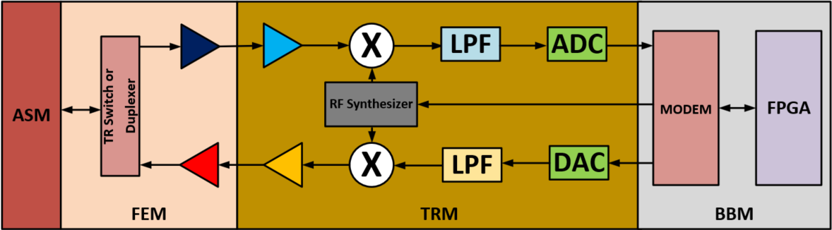

Historically, [ORTENGA](https://ortenga.net/) started with system architecture and definitions.

Then, [ORTENGA](https://ortenga.net/) enhanced its [Algorithm](https://ortenga.net/algorithms/) development portfolio.

Now, [ORTENGA](https://ortenga.net/) provides [ASIC](https://ortenga.net/asic/) services for clients either as a particular IP which can be used in the client IC or design and developing complete [ASIC](https://ortenga.net/asic/).

Over the past decade has grown into more complete system design and development which can be tailored to many applications, such as; [Autonomous Automotive](https://ortenga.net/autonomous-automotive-forum/), [Radar](https://ortenga.net/radar/), [Smart City](https://ortenga.net/smart-city-forum/).